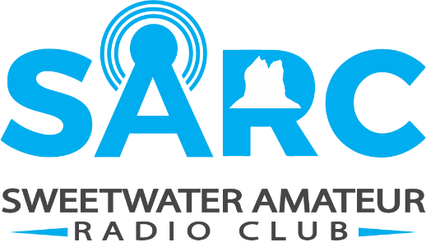
Contact:
Sweetwater Amateur Radio Club
307-922-6326
arrl@wy7u.org, or wy7u.org
MEDIA RELEASE
FOR IMMEDIATE RELEASE
3 May 2026
Local Amateur Radio Field Day Emergency Communications Event
SWEETWATER COUNTY, WYOMING – The Sweetwater Amateur Radio Club is inviting residents to witness and participate in an emergency communications preparedness exercise, Saturday, June 27th through Sunday, June 28th, at Green River, WWCC Campus (1 College Way, Green River, WY) for the nationwide ARRL Field Day.
Field Day is North America's premier emergency communications exercise, mobilizing more than 40,000 amateur radio operators across the U.S. And Canada to test their off-grid communications capabilities. During the two-day event, local amateurs will erect portable radio stations, operate solely on emergency power, and establish contacts with other amateur radio operators around the continent in real time.
Sweetwater Amateur Radio Club maintains a close working relationship with Sweetwater County Emergency Management, and their volunteer operators contribute to communications readiness for local training exercises, community events, and other emergency preparedness activities. Field Day is the public’s opportunity to observe this contribution firsthand. Visitors at Field Day will have the chance to experience:
- live demonstrations of actual radio equipment
- participate hands-on by making radio contacts
- learn about communication preparedness for disasters
- receive an overview of the role of amateur radio in supporting our communities.
No prior experience with amateur radio is necessary, and families and people of all ages are welcome. As a 501(c)(3) non-profit organization, the Sweetwater Amateur Radio Club promotes public service, technical training, and a more resilient community, and Field Day serves as a showcase of its volunteer-driven work throughout Sweetwater County.
Residents, local organizations, and community partners are invited to visit and learn about amateur radio and its important work to support Sweetwater County.
END OF RELEASE

