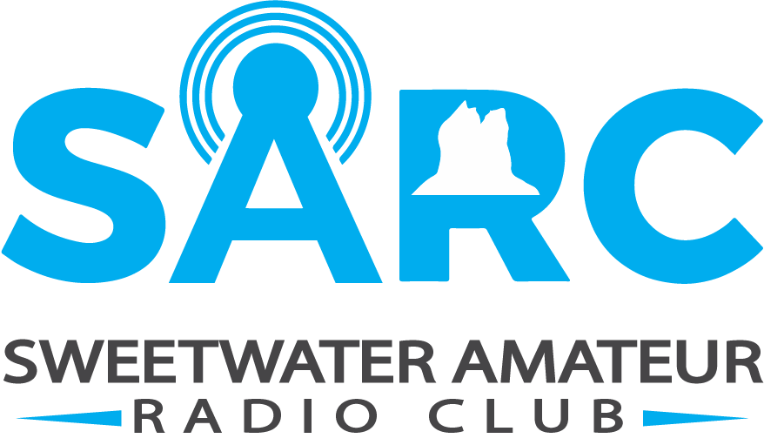

2-Meter Simplex Test
After-Action Report
November 11, 2025

Contents
Exercise Overview: 3
Analysis of Capabilities: 4
Objective 1 – Radio programing 5
Strengths: 5
Areas for Improvement: 5
Objective 2 – Relay Locations 6
Mapped locations 6
Strengths: 7
Areas of Improvement: 7
Objective 3 – Message Handling 8
Strengths: 8
Areas of Improvement: 8
Exercise Feedback Summary 9
Next Steps 9

Exercise Overview:

Exercise Name | October 2-Meter Simplex Test
Exercise Dates | October 14, 2025
Scope | To evaluate the feasibility, reliability, and effectiveness of 2-meter simplex amateur radio communications in supporting Emergency Management operations by relaying messages between a remote Command Post and the Emergency Operations Center (EOC) during a simulated emergency scenario.
Focus Area | Radio Programing, Response Times, Communication Capabilities.
Objectives | #1 – Operators to program their own radios to specific frequency  #2 – Determine optimal deployment locations for radio communications  #3 – Relay messages from Central Command back to Emergency Operations Center.
Sponsor | Sweetwater County Emergency Management
Participating Organizations | Sweetwater County Emergency Management  Sweetwater Amateur Radio Club (SARC) [WY7U]
Point of Contact | Zach Gunyan  Club President  307-922-6326  Ke7wyg@wy7u.org

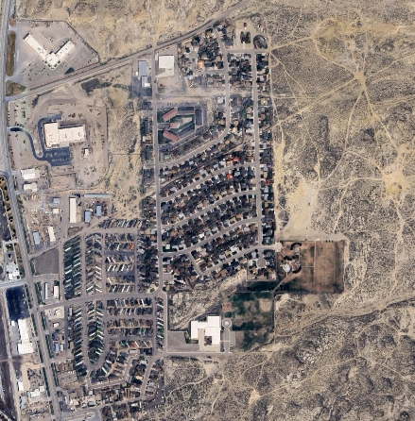
Scenario:
Search and Rescue is working on locating an individual who is around the area East of Wyoming Machinery, north of Desert View Elementary School and south of Lion Kol Road. With major thunderstorms rolling into the area, Aspen Mountain is currently without power. The repeaters located on Aspen Mountain are not operational, forcing radio operators to use simplex frequencies.
Objective:
Radio operators will deploy and help aid Search and Rescue with communications. Radio Operators will relay information back and forth from search area back and EOC utilizing Simplex Frequency 146.400.

Analysis of Capabilities:

Objective | Performed without Challenges (P) | Performed with Some Challenges (S) | Performed with Major Challenges (M) | Unable to be Performed (U)
Radio Programing |  | X
Relay Locations |  | X
Message Handling |  | X
Table 1 – Summary of Core Capability Performance

Ratings Definitions:
Performed without Challenges (P): The targets and critical tasks associated with the capability were completed in a manner that achieved the objective(s) and did not negatively impact the performance of other activities. Performance of this activity did not contribute to additional health and/or safety risks for the public or for emergency workers, and it was conducted in accordance with applicable plans, policies, procedures, regulations, and laws.
Performed with Some Challenges (S): The targets and critical tasks associated with the capability were completed in a manner that achieved the objective(s) and did not negatively impact the performance of other activities. Performance of this activity did not contribute to additional health and/or safety risks for the public or for emergency workers, and it was conducted in accordance with applicable plans, policies, procedures, regulations, and laws. However, opportunities to enhance effectiveness and/or efficiency were identified.
Performed with Major Challenges (M): The targets and critical tasks associated with the capability were completed in a manner that achieved the objective(s), but some or all of the following were observed: demonstrated performance had a negative impact on the performance of other activities; contributed to additional health and/or safety risks for the public or for emergency workers; and/or was not conducted in accordance with applicable plans, policies, procedures, regulations, and laws.
Unable to be Performed (U): The targets and critical tasks associated with the capability were not performed in a manner that achieved the objective(s).
The following sections provide an overview of the performance related to each exercise objective and associated capability, highlighting strengths and areas for improvement.

Objective 1 – Radio programing
Throughout the operational period, radio operators demonstrated commendable initiative and technical proficiency in ensuring their equipment was properly configured for the designated 146.400 MHz simplex frequency. Whether through individual preparation or collaborative troubleshooting, participants consistently rose to the occasion, embodying the spirit of mutual support and operational readiness that defines our community. The frequency was selected for its simplicity and reliability, and it served as a common thread that kept all stations aligned and responsive throughout the exercise.
In many cases, operators were able to program their radios independently, drawing on prior experience and familiarity with their equipment. For others, the process became an opportunity for peer-to-peer mentorship, with more seasoned members stepping in to assist with programming steps, menu navigation, and confirming settings. This informal knowledge-sharing not only ensured technical success but also reinforced the camaraderie and resilience that make our group so effective. By the time operations commenced, all participating stations were confidently configured and ready to engage, reflecting both individual preparedness and the strength of our collective support network.

Strengths:
- A majority of participating operators successfully programmed their radios independently, demonstrating preparedness and familiarity with their equipment.
- For those encountering challenges, on-site Subject Matter Experts (SMEs) provided immediate support, ensuring all radios were properly configured before operations commenced.
- The presence of SMEs fostered a collaborative environment and reinforced peer-to-peer learning, allowing less experienced operators to gain confidence and technical insight.

Areas for Improvement:
- Enhance intra-team communication: Improve clarity and consistency in message handling and coordination during operations.
- Utilize alternative simplex frequencies: Incorporate frequencies such as 146.55 MHz and 146.58 MHz to reduce congestion and improve channel availability.
- Pre-program operational frequencies: Ensure all participating radios have key frequencies programmed in advance to streamline setup and reduce delays.
- Increase operator familiarity with equipment: Encourage ongoing training and hands-on practice to build confidence and proficiency in radio programming and usage.

Objective 2 – Relay Locations

As operations commenced, participating operators mobilized to their assigned relay locations, navigating a range of terrain from open plains to rugged foothills. The drive itself became part of the exercise, with members demonstrating logistical coordination and situational awareness en route. Whether traveling solo or in small teams, operators arrived prepared, equipped with pre-programmed radios and a clear understanding of their role in the broader communication network. The deployment underscored the value of local knowledge and planning, with each location chosen for its strategic vantage and coverage potential.
Upon arrival, operators conducted initial signal checks to confirm connectivity and assess propagation conditions. These real-time signal reports provided valuable insight into the effectiveness of each relay position, allowing for quick adjustments and reinforcing the adaptability of the team. Reports were shared promptly, with operators noting signal strength, clarity, and any environmental factors affecting transmission. The process not only validated the technical setup but also fostered a sense of shared purpose—each station contributing to a resilient, responsive communications net across the region.

Mapped locations
The following sites were identified for potential relay placement:
- Century Park – Serving as the Remote Command Post
- Stagecoach & Foothill Blvd Intersection – First leg of the relay path
- College Hill Parking Lot (near the water tower) – Elevated vantage point for optimized signal clarity
- Crossroads Park – Ideal mid-point for signal capture and retransmission
- Cruel Jacks Area – Considered for its elevated terrain, providing advantageous coverage over surrounding lowlands
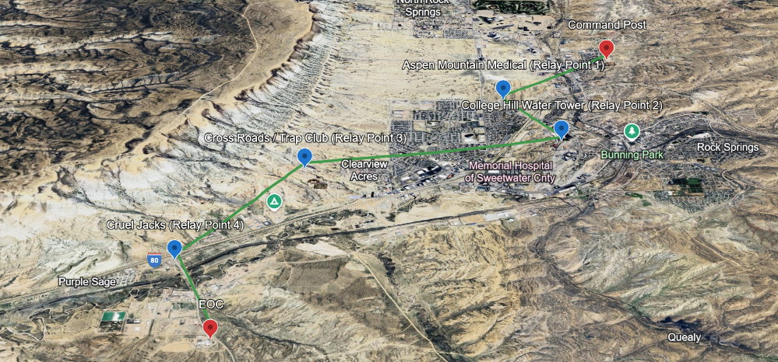

Strengths:
- Handheld radio performance was strong, with reliable communication reported from deployed relay sites.
- Teams demonstrated solid geographic awareness, successfully navigating to their assigned locations with minimal guidance.
- All operators arrived safely, reflecting effective planning and situational awareness.
- Relay sites remained accessible even if adverse weather were present, confirming the suitability of location choices and the resilience of the deployment plan.

Areas of Improvement:
- Incorporate mobile units where feasible to reduce the number of fixed relay locations and increase deployment flexibility.
- Offer educational opportunities in land navigation, including tools such as OnX, GPS, What3Words, and traditional map reading, to enhance operator confidence and precision in locating relay sites.
- Explore alternative portable hardware solutions, such as Alinco crossband repeaters and Baofeng handhelds, to expand deployment options and improve adaptability in varied terrain and conditions.

Objective 3 – Message Handling
Message handling during the exercise involved the transmission and relay of structured radio traffic between field stations and net control. Operators followed a standardized format, typically including preamble information such as message number, time, origin, and destination. Messages were transmitted via voice over the designated simplex frequency, with operators using phonetics and repeat-back techniques to ensure clarity and accuracy.
Traffic included a mix of tactical updates, signal reports, and administrative messages, with some operators utilizing written logs or ICS-style forms to track transmissions. Net control coordinated message flow, acknowledged receipt, and directed relays as needed to maintain orderly communication. Stations documented both sent and received messages, contributing to a complete record of operational traffic for post-exercise review.

Strengths:
- Operators were able to successfully pass messages between locations, ensuring that key information moved reliably throughout the exercise. This consistent communication supported coordination across teams and contributed to the overall success of the event.

Areas of Improvement:
- Conduct regular Net Operations and message handling drills to build fluency, confidence, and consistency across operators.
- Incorporate trust-building exercises to strengthen team dynamics and reinforce collaborative communication under pressure.
- Provide education on equipment being used, ensuring all operators understand the capabilities, limitations, and proper handling of their radios and accessories.

Exercise Feedback Summary
What Went Well
- Reliable communication was achieved across all teams, with successful message exchange between locations.
- Message delivery was 100% successful, confirming the effectiveness of our relay structure and operator coordination.
- Strong unit cohesion contributed to smooth operations, with teams working collaboratively and supporting one another throughout the exercise.
Areas for Improvement
- Food planning and provisioning should be addressed to better support operator comfort and endurance during extended deployments.
- Consider using mobile radios over handhelds where appropriate to improve signal strength and operational range.
- Deploy external antennas instead of rubber duck antennas to enhance transmission quality and reliability, especially in challenging terrain.

Next Steps

- Develop and deliver a class on mobile antenna systems, focusing on deployment techniques, performance considerations, and equipment selection to enhance field communications.

- Offer a dedicated message handling workshop, reinforcing best practices for composing, transmitting, and receiving messages in both informal and formal traffic scenarios.

- Conduct additional simplex testing under winter conditions to evaluate equipment performance, signal reliability, and operator readiness in cold-weather environments.

