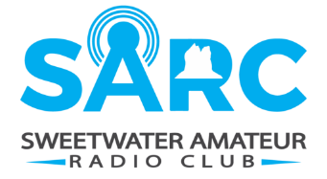
March 12, 2024
Meeting Agenda
Location:
Tom Whitmore Post 29 of the American Legion,
38 N Center Street, Green River, WY 82935

- Attendees
- Opening of Meeting
- Approval of Agenda
- Review of minuets
- Deferred Items
- Treasurers Report
- New Business
  - Website
    - Posting Weekly Net Recordings
    - Posting Minuets / Agenda
  - CERT / EMA Radio Communication Preparation for Meeting
    - FRS / GMRS / CB
    - Radio Etiquette
- Upcoming Events
    - Cheyenne, WY - Technician License Class, April 1, Mondays, Thursdays and Saturdays. Test on May 18th, 9am. Contact Beth Harris, KJ7FC kj7fcwy@gmail.com (Posted to website)
    - June 22-23, 2024 - Field Day
    - June 17 – June 27 - Pony Express, (Sweetwater County ~ 20-23rd)
- Round Table
  - Organized Discussion Topics
- Next Meeting
- Adjournment

